Over the years, thanks to your contributions, we’ve been able to support many of our policing family through difficult times.  We’ve provided financial assistance with purchasing equipment to improve mobility and quality of life for several retired members and their families.  We’ve provided monetary gifts to members, suffering from unforeseen sickness or circumstances out of their control.  Because of your selfless contributions, we’ve been able to create wonderful lasting memories for the family, and loved one’s left behind, with others taken too soon.  Thank you | Contact us  Wiltshire Police Benevolent Trust  Wiltshire Police Headquarters  London Road  Devizes  SN10 2DN  Call us on 01225 256561.  Email us at: POLFED@wiltshire.police.uk  Website at www.polfed.org/wilts | Here to help, you
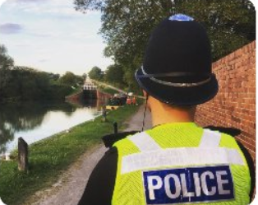  Wiltshire Police Benevolent Trust became a registered charity in 2007, this changed our status which allowed the Trustees to help not only serving officers, retired officers, but police staff and their families too.  Over the years, thanks to your contributions we have been able to support hundreds of our policing family through challenging times, we have assisted with purchasing equipment to improve mobility and quality of life for several retired members and their families.  It is financed by subscriptions from members as well as donations. Money raised supports serving officers, retired officers, police staff – and their families. | Financial requests are considered by the Trustees after an application has been made by members who are suffering from financial hardship or who might be in need of help.  The categories we can consider, although the list is not exhaustive.  - Grants  - Small gifts towards travel, parking  - Medical convalescence  - Medical consultation  Our team of Trustees – all serving or retired officers – then have the final say and are accountable for how funds are spent.  The Wiltshire Police Benevolent Trustees are:  Representative of Chief Constable - Superintendent Kerry Lawes  Superintendents Association - Superintendent Steve Cox  Police Federation - Pc Sarah Ennis - (Ben Trust Secretary)  UNISON - Clair Cross  NARPO - Mr Cavan Moroney | Make a referral.  Anyone involved with the Wiltshire police family can make a referral on behalf of someone else. You may be a supervisor or a member of the Force’s HR team OCH and know of a colleague who needs help.  Email POLFED@wiltshire.police.uk  - Your name:  - Your contact details: email and contact number  - Name of person you’re referring, and their collar number /staff ID  - Please write the reason for you referring them to the Benevolent Trust.

