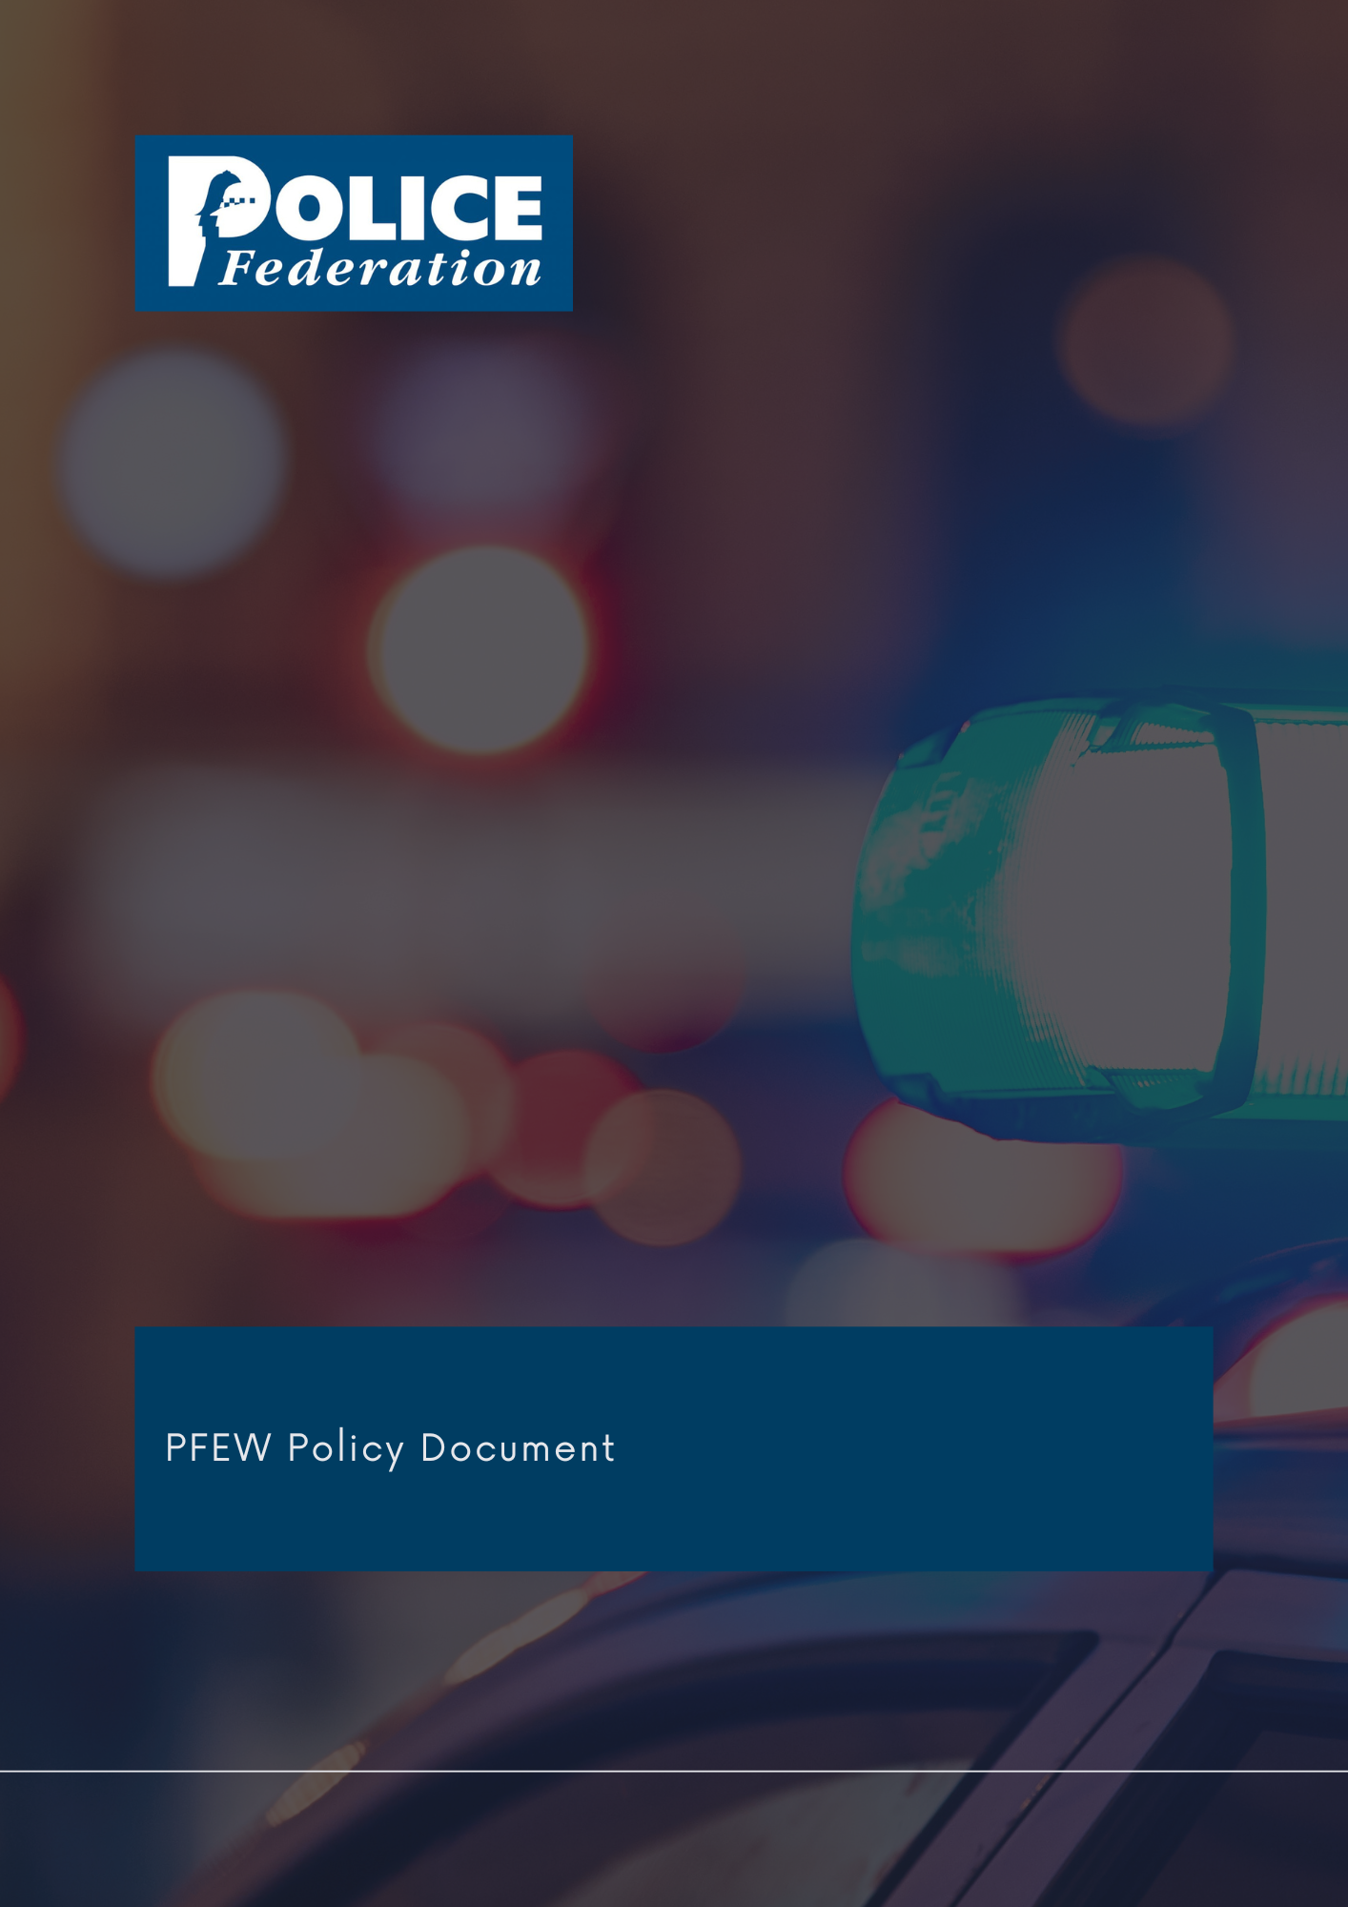
Body Worn Video Devices Policy

Version 1
2023

The PFEW Policy Department has embarked on a programme to formulate and revise policy documents on matters of particular importance to its members.

It is the aim of PFEW to maintain clear policies on key topics that allow members to understand PFEW's official position on those areas.

These strategic documents are evidence-based, aligned with PFEW's Business Areas and championed by National Board members.

If you have any comments or queries, please direct them to
Bahar.Munim@polfed.org

BODY WORN VIDEO DEVICES

1. Policy statement

PFEW supports the use of body worn video (BWV) devices for operational police officers. The use of BWV technology has the potential to improve significantly the quality of evidence ga+thered by police officers and to improve trust and confidence in the police by recording the actions of police officers. For instance, BWV has improved the investigation of and contributed to an increase in charging rates for domestic abuse.

Police forces across England and Wales have come to accept that BWV is an essential piece of equipment for police officers and it is now common for front line officers to have access to it.

2. Responsibility

The National Board is responsible for all policy formation.
3. Summary
PFEW supports the use of body worn video technology by operational police officers but with proper guidelines and training for best evidence gathering. Of note is the NPCC BWV 2022 document that does assist in this area. BWV is a supplemental tool for evidence gathering and should not be seen as a replacement for officer integrity or an impediment to officer discretion. Witness evidence can on occasion be affected by issues such as perceptual distortion, and we will work with the NPCC and IOPC to help stakeholders understand this important issue.

PFEW believes all officers who are the subject of post incident procedure investigations should be afforded the opportunity to view BWV applicable to them or colleagues involved in the incident. This should be made available prior to the officer making a stage 4 detailed account as a principle officer in order to facilitate the recording of best evidence, obtaining the truth and learning lessons. We believe that BWV technology will demonstrate the professionalism of police officers and show the challenges that are faced by officers on a daily basis. It will help make the service more accountable, but also help explain the rationale for officers using discretion in exercising their role. BWV will help to protect officers in terms of malicious and vexatious complaints and help reduce the cost and length of time taken to resolve complaints against police officers.

In line with the College of Policing, PFEW believes that BWV can provide an invaluable tool to supervisors and colleagues who investigate complaints, but that it should not be used for speculative examination without cause because of the harm this can do to the privacy of officers. For similar reasons, PFEW strongly rejects the notion of BWV cameras being activated for the entirety of an officer’s shift.

PFEW considers that public disclosure of BWV footage, which identifies police officers and/or staff, should only be carried out where there is a legitimate need to do so, paying particular regard to the security and privacy rights of officers and staff, their wishes and welfare and after giving them an opportunity to object.

4. Procedures/implementation

We will press the College of Policing and the National Police Chiefs Council to provide training and Authorised Professional Practice to officers to ensure that the best evidence is gathered and that BWV technology is utilised appropriately. We will work with the NPCC and the Home Office to ensure that there is a joined up approach to avoid problems of interoperability. We will work with the NPCC to try and find solutions to deploy BWV on mutual aid deployments, whereby officers are denied access to BWV equipment, due to lack of infrastructure. There must be standardisation of the recording system to make sharing of the information between forces and other agencies as simple and efficient as possible. The increased use of BWV has led to a further burden on the service in relation to disclosure, and many hours of officer time is used to review footage and consider its relevance to a case. We will work with NPCC, CPS and suppliers to minimise this burden on our colleagues and their valuable time. To this end, we will press Chief Constables to take account of Home Office guidance on the procurement and deployment of BWV devices to ensure that they meet an appropriate minimum technical specification in order to achieve the best possible evidence.

Responsibility for maintaining this policy is delegated to the National Secretary and/or business area.

Approved by PFEW National Board: June 2023
Review: June 2024

