**Gym, swim and classes available at a discounted rate in Lincolnshire.**

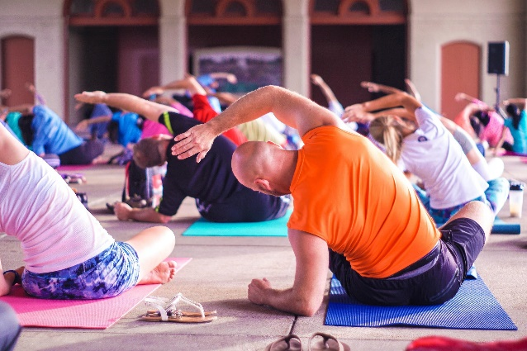

Discounted rates have been offered across Lincolnshire Leisure Centres and gyms for Police staff and officers. Please contact leisure facilities directly to discuss further.

|  |  |
| --- | --- |
| Lincoln |  |
| **Active Nation Leisure Centres**  Birchwood 01522 304451  Yarborough Leisure Centre  01522 304401 | corporate discount offered £27 a month (£270 per year) with use of facilities at both centres.  Sometimes discounted offers for the year beat the corporate rate e.g. it is currently £100 for the year gym or swim option or £150 for Gym, swim and classes. |
| **Bishop Grosseteste University Gym**  01522 583680 | corporate discount £16 per month/£17.50 (no contract) £175 Annual payment |
| **Lincoln college**  01522 876373 | Deans sport and Leisure- Blue light discount: gym £12 a month |
| North Kesteven |  |
| **Better gyms** –  **One NK** in North Hykeham , Lincoln  01522 883311  **Better Gym** in Sleaford 01529 304770  **Sleaford leisure centre** 01529 303081 | Corporate deal called ‘the better half community network’- membership £30 a month. (£300 a year) |
| West Lindsey |  |
| **Everyone active Leisure centre.**  West Lindsey Leisure centre, Gainsborough.  01427 615169 | Concession rates- £28.99 (membership) Show work ID. |
| **Everyone active Leisure centre.**  Market Rasen Leisure centre  01673 842695 | Concession rates- £28.99 (membership) Show work ID. |
| Boston |  |
| **Geoff Moulder Leisure Centre,** Boston  01205 363483 | £25.00 concession membership (£10 joining fee) (£275 year) |
| Boston College | pay as you go to use facilities |
| East Lindsey |  |
| **Jubilee Park Fitness centre, Woodhall spa**  01526 353478 | £31.50 (12 month contract) |
| South Holland |  |
| **Castle Leisure Centre,** Spalding  01775 762178 | corporate discount- fixed membership £28.15 (12 month contract) £30.45 flexible contract. |
| Grantham |  |
| **Leisure SK** -Grantham leisure centre  01476 581930 (speak to Chloe at Grantham Meres- sign up will include all 3 SK Leisure sites). | 7 day free -no commitment pass.  First month free when signing up to a month to month contract. |
| Stamford |  |
| **Leisure SK**- Stamford and Bourne  01476 581930 (speak to Chloe at Grantham Meres- sign up will include all 3 SK Leisure sites). | 7 day free -no commitment pass.  First month free when signing up to a month to month contract. |